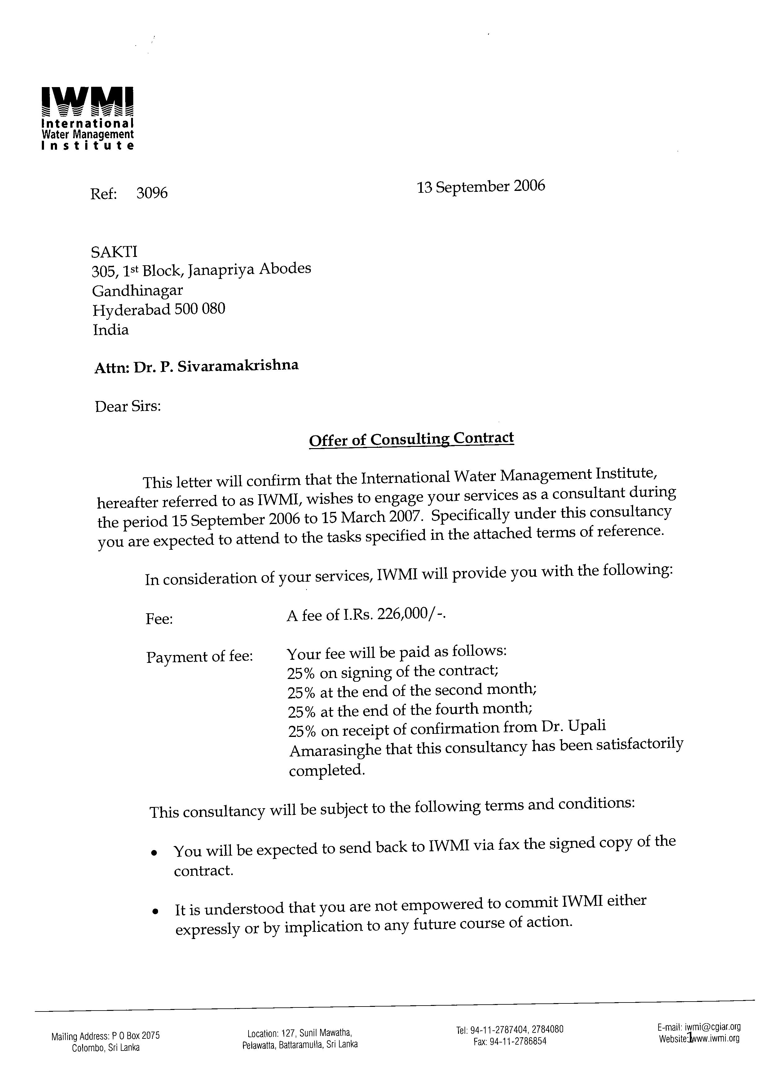

Terms of Reference for a Site Coordinator of the Field Studies in the Strategic Analysis of the River Linking Project of India

Project
The International Water Management Institute (http://www.iwmi.org) in collaboration with the Challenge Program for Water and Food has started a three year research project for assessing India’s Water futures to 2025-2050 and analyzing alternative policy options, including the National River Linking project (NRLP), are appropriate for meeting the proposed water futures.
The Phase I of project completed in April 2006, focused on assessing Idndia’s water futures to 2025/2050. The Phase II of the project which is currently on-going , analyses the social cost and benefit of the NRLP. This includes detail field studies in few selected river links identified under NRLP. The field studies under several research themes are lead by a team of IWMI researchers. The research themes are as follows:

Themes
- Direct and indirect benefits of surface irrigation projects - Upali Amarasinghe
- Induced economic expansion with irrigation projects - Upali Amarasinghe
- Environmental impacts of large water transfer projects -Vladimir Smakhtin
- Impact of inter basin transfers (IBTs) on domestic & Industrial water supply- Sanjiv Phansalkar
- Gender and equity issues in IBT—Deepa Joshi
- Groundwater externalities (+/-) of surface irrigation transfers -Bharat Sharma
- Rehabilitation best practices in IBTs – Madar Samad
- Hydrological models of IBTs-Vladimir Smakhtin and Luna Bharati
Field investigations under each theme will be conducted within and outside the command as in the schematic diagram illustrated below (Figure 1 ). A Site Coordinator will be appointed for each IBT study location to coordinate the filed studies under the different themes. The TOR for the Site Coordinator is given below.
River upstream
Command Area
Downstream
Command area
Non-command area
Upstream
Down stream
PAP
Dam
Submergence area
A
B
C
D
E

Terms of Reference for the Site Coordinators – Godhawari – Krishna basin

Duration: 6 months (September 15th 2006 to March 15th 2007)

Scope of the work: The Site Coordinator will be stationed in the study location and is expected to familiarize with the area and the water related issues in the study site.
The site coordinator is responsible for the following tasks:

Site Coordination
- Obtaining the district/Sub-District (Mandal, Taluk etc)/village maps and other required project document related to the study area.
- Interact with the local/regional level institutions and researchers working in the river linking project as necessary for the project
- Organize dialogues/meetings with people/officials as required by the project leader
- Assist obtaining secondary data at the village or sub-district level as required by the project theme leaders
- Organize and maintain a office in the study for 4 months, rent two computers for the office space.
- Assist with pre-testing questionnaires and other data collection instruments
- Assist identifying a suitable data collection team (supervisors, enumerators, data entry operators) required for different themes
- Coordinate the logistics of field data collection of different themes
- Supervise the data entry of the collected questionnaires
- Coordinate other research activities as required by the theme leaders

Remuneration: INRS 226,000 (Two hundred and twenty six thousand only)
The contract is calculated on the following basis. 1). RS 150,000 (25,000 x 6 months, salary for the coordinator), 2). RS 40,000 (@10,000 x4 months for the office rent/maintenance/furnishing), 3). RS 16,000 (@RS 4,000 x 4 months for renting two computers for 4 months), and 4). Rs 20,000. for the field informant payments during the data collection).

Payment schedule:
25% of the total contract the after the signing the contract
25% after the 2nd month of the contract
25% after the 4th month of the contract
25% after successfully completing contract as indicated in the TOR.

